**Q3. Given a network address of 10.0.0.0/24, divide it into 4 equal subnets.Calculate the new subnet mask.Determine the valid host range for each subnet.Assign IP addresses to devices in Packet Tracer and verify connectivity.**

**Network setup:**

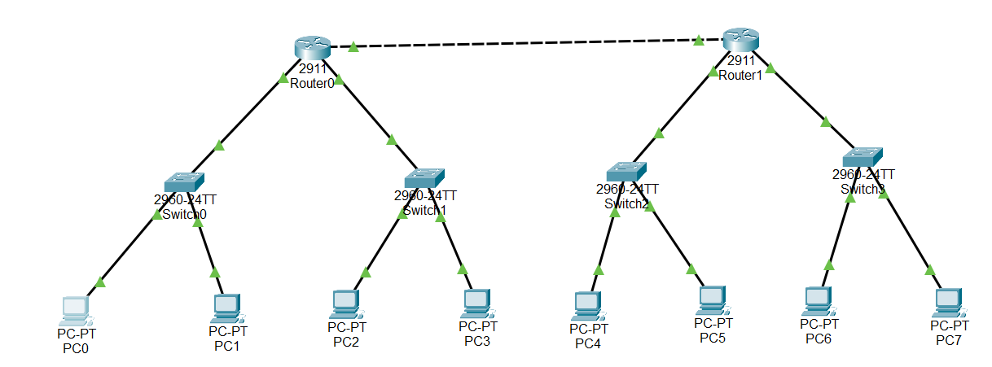

**Configuring Router1:**

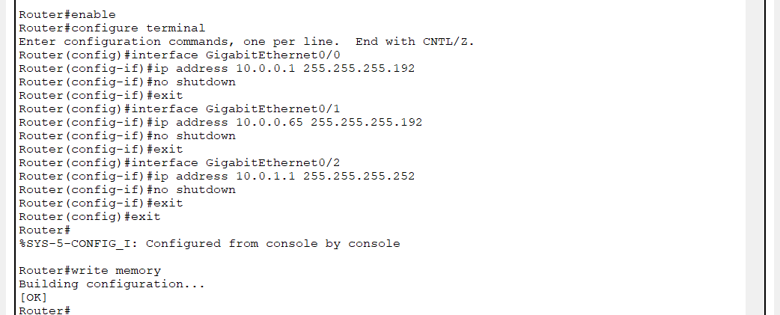

**Configuring Router2:**

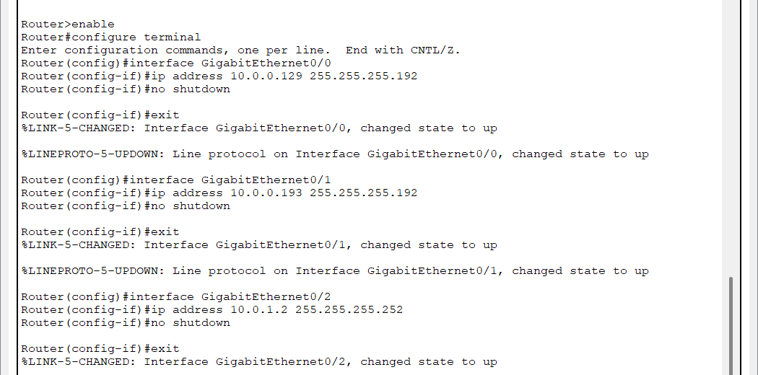

**Static Routes on Router1:**

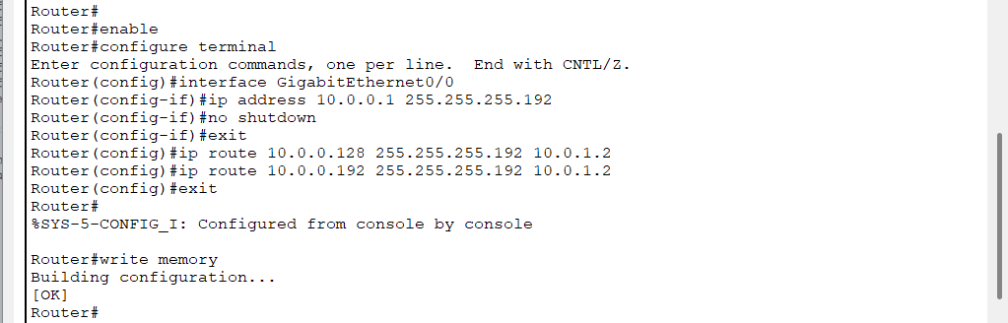

**Static Routes on Router2:**

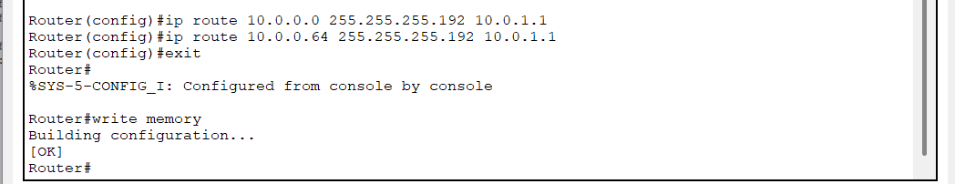

**Ping Between PC0 and PC4:**

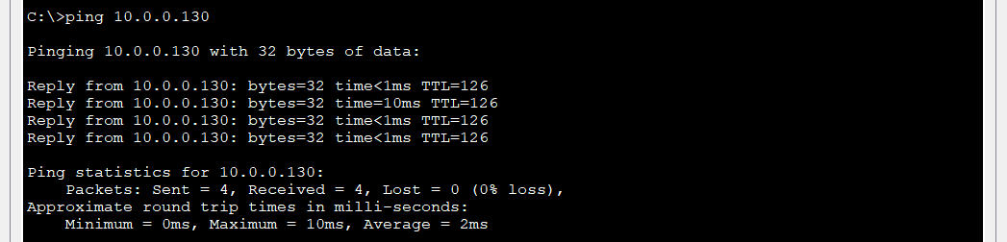

**Using tracert command to race the route:**

